Grazioso Salvare Animal Rescue Dashboard
Project Overview
This project delivers a full-stack web application dashboard for Grazioso Salvare, an international rescue animal training organization. The dashboard enables staff to interact with Austin Animal Center outcomes data to identify and categorize dogs suitable for search-and-rescue training based on breed, age, and sex criteria.
Created by: Heath Davis

Required Functionality
The dashboard provides the following features:
1. Interactive Filtering System
- Radio button filter controls for three rescue type categories:
  - Water Rescue: Labrador Retrievers, Chesapeake Bay Retrievers, and Newfoundlands (Intact females, 26-156 weeks old)
  - Mountain or Wilderness Rescue: German Shepherds, Alaskan Malamutes, Old English Sheepdogs, Siberian Huskies, and Rottweilers (Intact males, 20-300 weeks old)
  - Disaster or Individual Tracking: Doberman Pinschers, German Shepherds, Golden Retrievers, Bloodhounds, and Rottweilers (Intact males, 26-156 weeks old)
  - Reset: Returns unfiltered view of all 10,011 animal records
2. Dynamic Data Table
- Displays animal records with pagination (10 rows per page)
- Supports sorting and filtering capabilities
- Row selection functionality for map integration
- Clean styling with alternating row colors and professional headers
- MongoDB ObjectId fields removed for display clarity
3. Visualization Components
- Breed Distribution Pie Chart: Dynamically updates based on filtered data, showing proportional representation of dog breeds
- Geolocation Map: Leaflet-based interactive map centered on Austin, Texas (30.5°N, 97.5°W) with:
  - Marker placement for all animals in current dataset
  - Pop-up labels showing animal names
  - Single-animal highlighting when row is selected from data table
4. Professional Presentation
- Grazioso Salvare branded header with logo (80px height)
- Responsive layout with flex-box design
- Color scheme incorporating brand red (#C41E3A)
- Developer attribution for maintainability
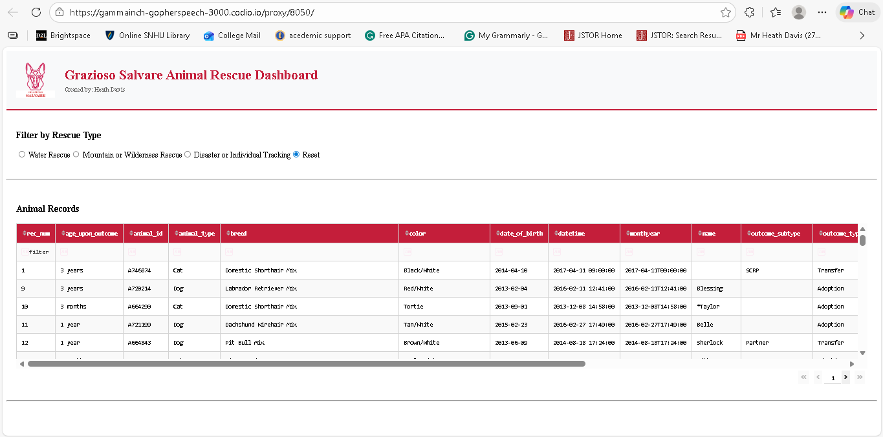
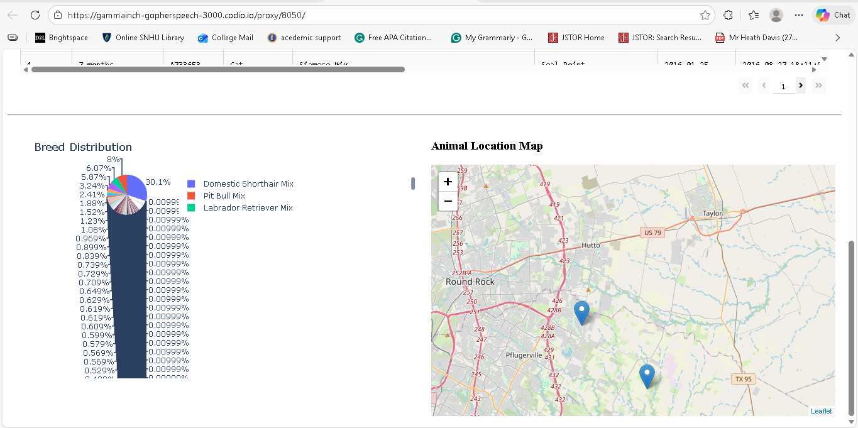
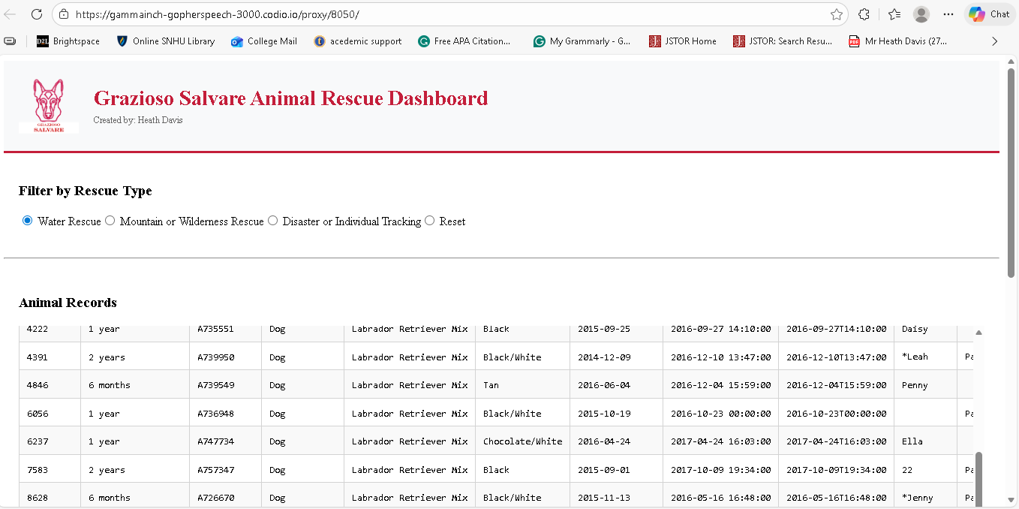
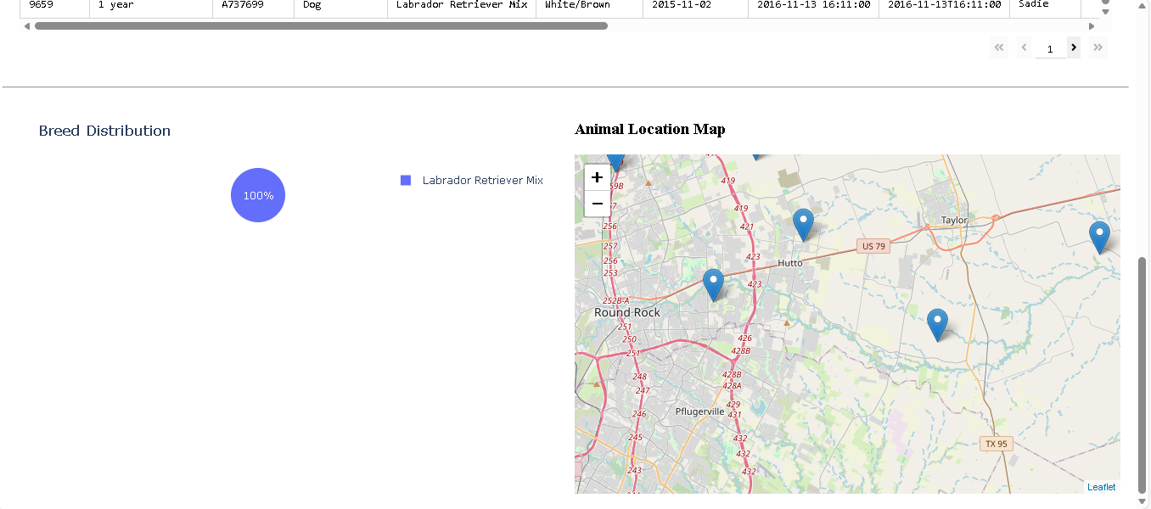
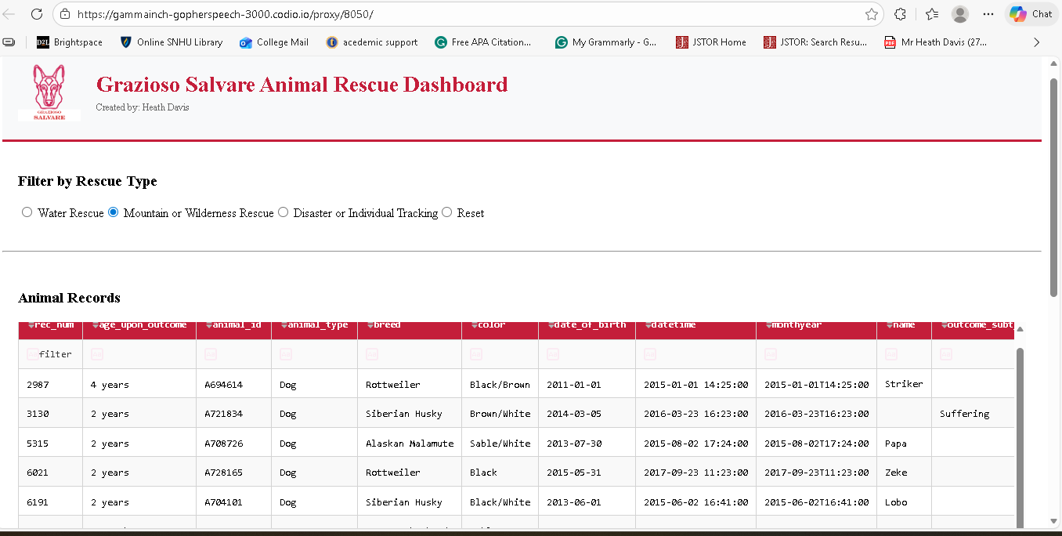
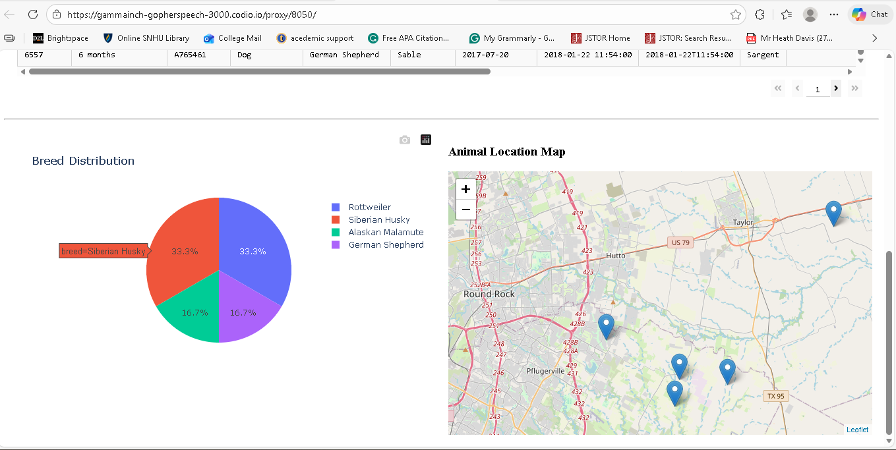
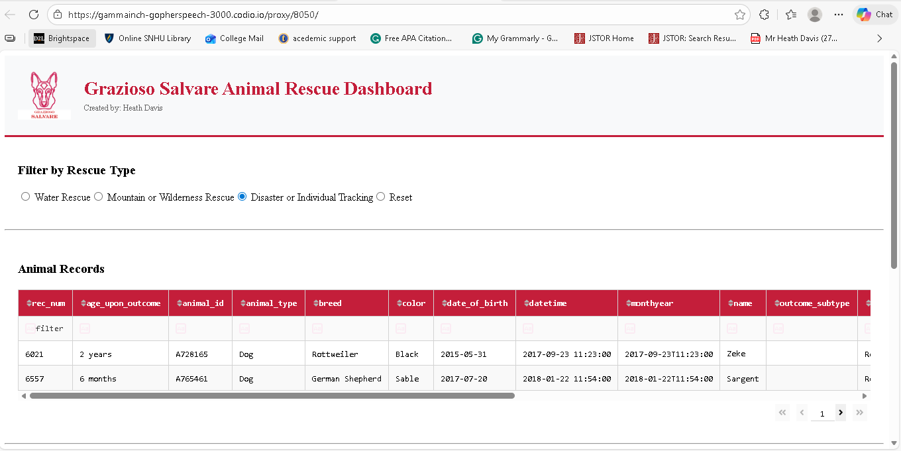
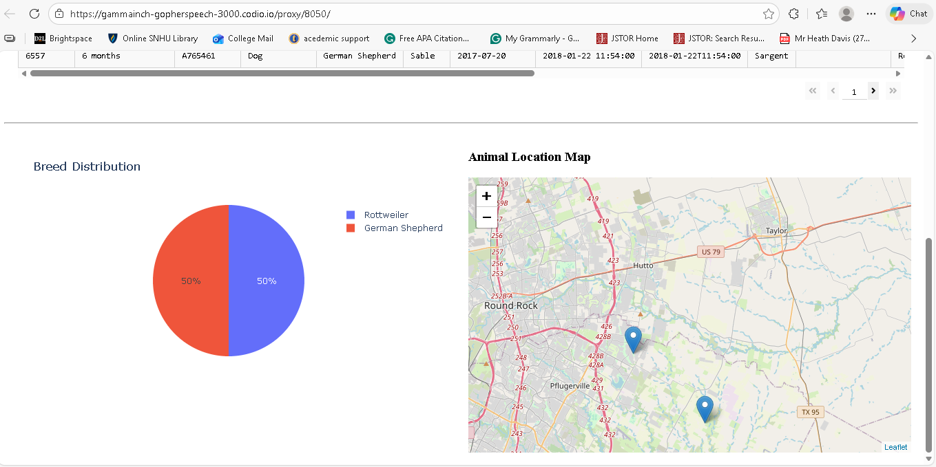

Tools and Technologies
Technology Stack
Component | Tool | Version | Purpose
Model | MongoDB | Latest | NoSQL database storing 10,011+ animal shelter records
View | Dash/HTML | 2.8.1+ | Web UI components and layout
Controller | Python | 3.11.2 | Business logic and callback handlers
Visualization | Plotly Express | Latest | Interactive pie chart rendering
Geospatial | Dash Leaflet | Latest | Interactive mapping and markers
Data Processing | Pandas | Latest | DataFrame operations for filtering
Jupyter Integration | JupyterDash | Latest | Notebook-based Dash deployment
Rationale for Tool Selection
MongoDB: Chosen as the document-based NoSQL database because:
- Flexible schema accommodates varied animal shelter data structures
- Native Python integration via PyMongo library simplifies CRUD operations
- Efficient querying with MongoDB operators ($in, $eq, $gte, $lte) for complex breed/age/sex filters
- Scalability to handle large shelter datasets across multiple facilities
- Horizontal scaling capability for future geographic expansion
Dash Framework: Selected for the view and controller components because:
- Pythonic approach eliminates JavaScript/frontend complexity
- Reactive callbacks automatically handle component dependencies and updates
- Built-in DataTable component with advanced features (pagination, sorting, selection)
- Seamless Plotly integration for interactive visualizations
- JupyterDash enables rapid development within notebook environment
- Component-based architecture follows web application best practices
PyMongo: Provides direct Python interface to MongoDB with:
- Connection pooling and authentication support
- Cursor-based result handling for memory efficiency
- ObjectId support for MongoDB document identification
- Exception handling for robust error management

MongoDB Implementation Details
Database Architecture
Database: aac (Austin Animal Center)
Collection: animals
Document Count: 10,011 shelter outcomes
CRUD Operations
The AnimalShelter class encapsulates all database interactions:
class AnimalShelter(object):
def __init__(self, username, password):
# Establishes authenticated connection to MongoDB
# Parameters: aacuser / MySecurePassword123

def create(data):
# Inserts new animal records
# Returns: Boolean success indicator

def read(query):
# Executes find() queries with MongoDB operators
# Returns: List of matching documents

def update(query, data):
# Modifies documents using $set operator
# Returns: Count of updated documents

def delete(query):
# Removes documents matching criteria
# Returns: Count of deleted documents
Query Examples
Water Rescue Filter:
{
'breed': {'$in': ['Labrador Retriever Mix', 'Chesapeake Bay Retriever', 'Newfoundland']},
'sex_upon_outcome': {'$eq': 'Intact Female'},
'age_upon_outcome_in_weeks': {'$gte': 26, '$lte': 156}
}
Result: 17 matching records
Mountain/Wilderness Filter:
{
'breed': {'$in': ['German Shepherd', 'Alaskan Malamute', 'Old English Sheepdog', 'Siberian Husky', 'Rottweiler']},
'sex_upon_outcome': {'$eq': 'Intact Male'},
'age_upon_outcome_in_weeks': {'$gte': 20, '$lte': 300}
}
Result: 6 matching records
MongoDB Advantages for This Application:
- Flexible field mapping (e.g., sex_upon_outcome field can vary across documents)
- Efficient array filtering with $in operator for breed matching
- Range queries with comparison operators for age-based filtering
- Atomic operations prevent data inconsistency during concurrent access
- Indexing on frequently-queried fields (breed, sex_upon_outcome, age_upon_outcome_in_weeks) optimizes performance

Dash Framework Architecture
MVC Design Pattern Implementation
MVC Layer | Implementation | Component
Model | MongoDB via PyMongo | AnimalShelter CRUD class
View | Dash HTML Components | DataTable, Graph, Map widgets
Controller | Dash Callbacks | @app.callback() decorators
Callback Flow
User Input (Radio Filter)
↓
update_datatable() callback
↓ (queries MongoDB via AnimalShelter.read())
DataTable updates with filtered records
↓
update_graph() callback
↓ (receives DataTable data)
Pie chart renders breed distribution
↓
update_map() callback
↓ (receives DataTable data and selected rows)
Leaflet map displays animal locations
Key Dash Concepts Used
Component Properties:
- id: Unique identifier for component targeting in callbacks
- value: Current state of input components (radio selection)
- data: Dynamic content passed between components
Callback Decorators:
@app.callback(
Output('component-id', 'property'), # Target component to update
Input('source-id', 'property') # Component triggering update
)
State Management:
- Radio filter maintains selected rescue type
- DataTable stores filtered records and selected rows
- Callbacks recompute visualizations without page reload

Project Implementation Steps
Step 1: Database Preparation
- Connected to MongoDB instance with authenticated credentials
- Verified 10,011 animal records available in aac.animals collection
- Identified relevant fields: breed, sex_upon_outcome, age_upon_outcome_in_weeks, location_lat, location_long, name
Step 2: CRUD Module Development
- Created AnimalShelter class with MongoDB connection management
- Implemented four methods: create, read, update, delete
- Added error handling with try-except blocks
- Returned appropriate data types (bool, list, int)
Step 3: Dashboard Initialization
- Imported required libraries (JupyterDash, Plotly, Pandas, Dash Leaflet)
- Instantiated JupyterDash application with notebook proxy configuration
- Loaded Grazioso Salvare logo as base64-encoded image
- Retrieved initial unfiltered dataset (10,011 records)
Step 4: Filter Query Development
- Defined three filter dictionaries matching rescue type specifications
- Constructed MongoDB queries using $in, $eq, $gte, $lte operators
- Tested each filter to verify record counts (17, 6, 2, 10011)
- Included "Reset" option for unfiltered view
Step 5: UI Component Construction
- Created header with logo and title
- Implemented radio item filter control
- Built interactive DataTable with:
  - Pagination (10 rows per page)
  - Custom styling (brand red header, alternating row colors)
  - Row selection capability
- Created container divs for dynamic graph and map components
Step 6: Interactive Callback Development
- update_datatable(): Reads MongoDB based on filter selection
- update_graph(): Renders pie chart from DataTable data
- update_map(): Places markers on Leaflet map, highlights selected rows
Step 7: Testing and Deployment
- Ran notebook cell to launch Dash application
- Verified filter functionality retrieved correct record counts
- Tested radio filter transitions and data table updates
- Confirmed pie chart updates with different filters
- Validated map markers appear correctly
- Tested row selection highlighting on map
- Verified Reset option returns to initial state

Challenges and Solutions
Challenge 1: MongoDB Field Name Mismatch
Problem: Initial queries used sex field, but actual field was sex_upon_outcome, returning zero results.
Solution: Reviewed MongoDB schema documentation and sample documents to identify correct field names. Updated all filter queries to use sex_upon_outcome, age_upon_outcome_in_weeks, and location_lat/location_long for consistency.
Challenge 2: Logo Loading in Notebook Environment
Problem: Relative file paths failed when running in Codio environment.
Solution: Used absolute file paths (/home/codio/workspace/code_files/Grazioso_Salvare_Logo.png) and wrapped in try-except block to gracefully degrade if logo unavailable.
Challenge 3: Data Table to Map Integration
Problem: Initial map implementation showed all animals regardless of data table filter.
Solution: Modified map callback to receive datatable-id data as input parameter instead of re-querying database. This ensures map always reflects current table state.
Challenge 4: Memory Efficiency with Large Dataset
Problem: Converting 10,011 records to DataFrame caused performance issues.
Solution: Implemented pagination in DataTable (10 rows per page) to limit rendering load. Map only processes visible/selected rows rather than entire filtered dataset.
Challenge 5: ObjectId Serialization
Problem: MongoDB ObjectId objects cannot be directly converted to JSON for Dash callbacks.
Solution: Deleted _id field from records before passing to frontend components using conditional checking and deletion in callback functions.

Resources and References
Documentation
- MongoDB Official Documentation
- PyMongo Documentation
- Dash Framework Documentation
- Plotly Express API Reference
- Dash Leaflet GitHub Repository
- Jupyter Dash Documentation
Tools and Software
- Python 3.11.2
- MongoDB Community Edition
- Jupyter Notebook / JupyterLab
- Plotly 5.x
- Pandas 1.x
- Dash 2.8.1+
External Data
- Austin Animal Center Outcomes Dataset (10,011 records)
- OpenStreetMap tiles via Leaflet

Installation and Setup Instructions
Prerequisites
pip install pymongo pandas dash plotly jupyter jupyter-dash dash-leaflet
Configuration
- Ensure MongoDB is running on localhost:27017
- Create or authenticate aacuser account with password MySecurePassword123
- Load animal shelter data into aac.animals collection
Running the Dashboard
# In Jupyter notebook environment
%run ProjectTwoDashboard.ipynb
# Or from terminal
jupyter nbconvert --to notebook --execute ProjectTwoDashboard.ipynb
Access
Navigate to displayed URL (typically http://127.0.0.1:8050/)

File Structure
grazioso-salvare-dashboard/
├── CRUD_Python_Module.py # MongoDB CRUD operations class
├── ProjectTwoDashboard.ipynb # Dash application notebook
├── Grazioso_Salvare_Logo.png # Brand logo asset
└── README.md # This documentation

Future Enhancements
- Add export functionality (CSV/PDF) for filtered datasets
- Implement user authentication and role-based access
- Add advanced filtering with date range and location-based queries
- Create additional visualizations (age distribution, outcome trends)
- Deploy to production using Heroku or AWS with persistent MongoDB Atlas
- Implement caching layer for frequently-accessed queries
- Add batch import/update capabilities for new shelter data

License
This project is open source and available for use and adaptation by similar rescue organizations. See LICENSE file for details.

Project Status: Complete ✓
Last Updated: February 22, 2026
Dashboard Version: 1.0
MongoDB Records Tested: 10,011

